CAPSTONE PROJECT

**(TEAM 17)**

PROJECT TITLE – **Banking Account Management System**

Made by - SAPARAY M SIDDHARTH

& SAKCHAM SINGH

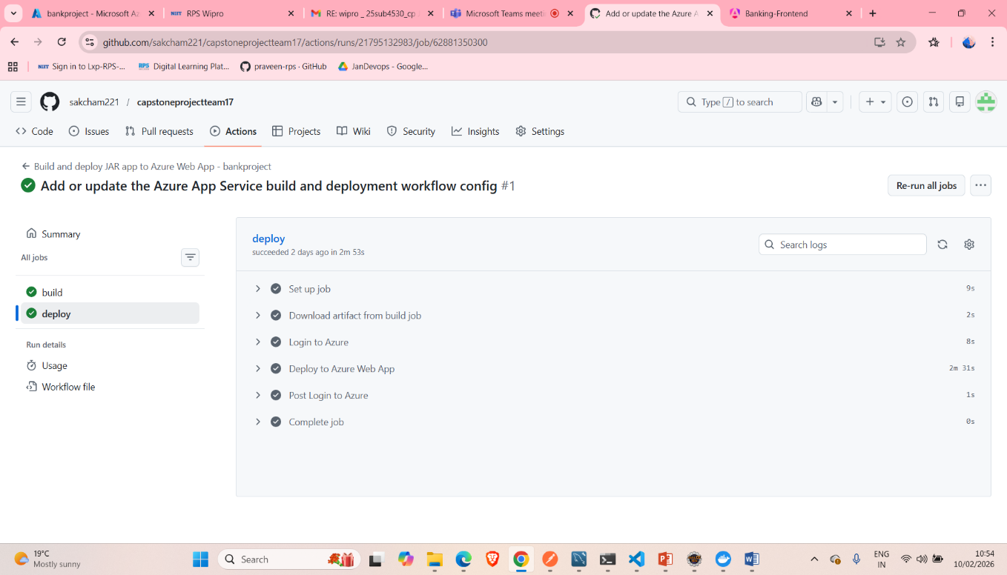

In GitHub actions successfully build and deploy the backend

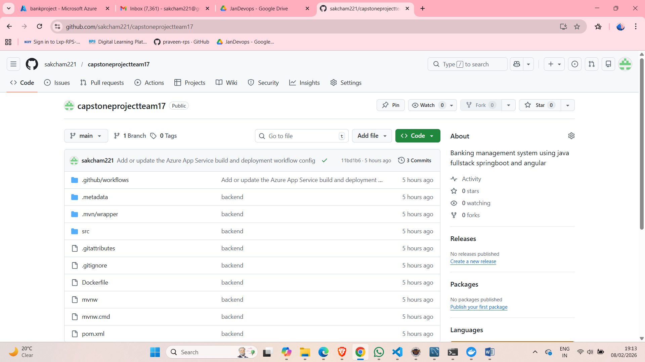

GitHub After deploying the spring boot in azure

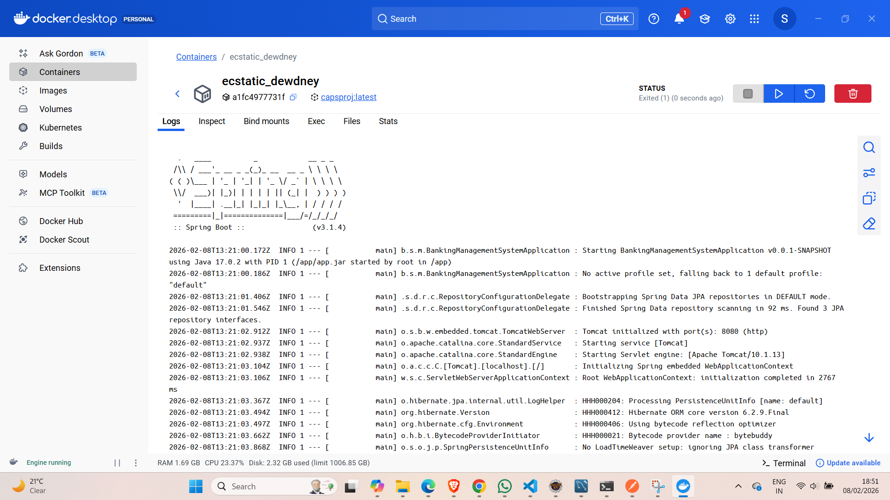

Running the Docker container

Docker image of project

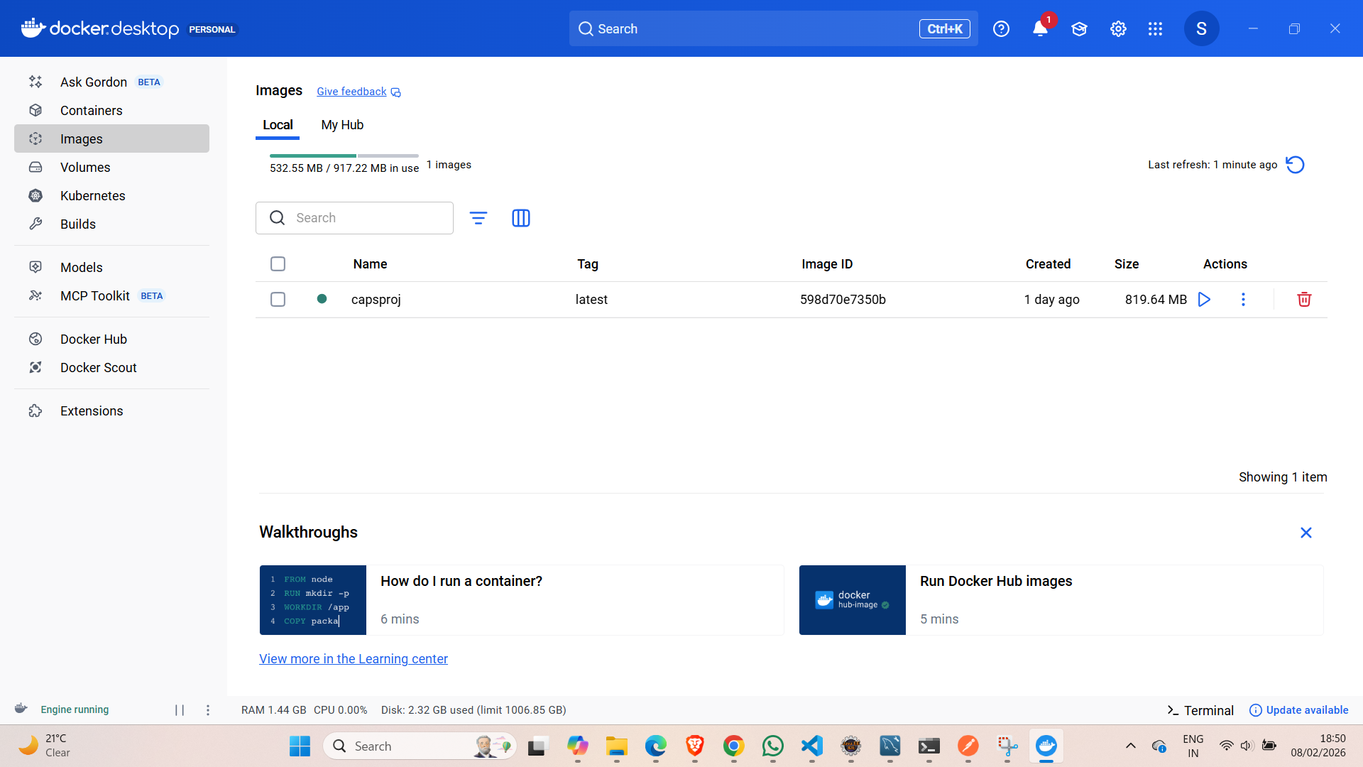

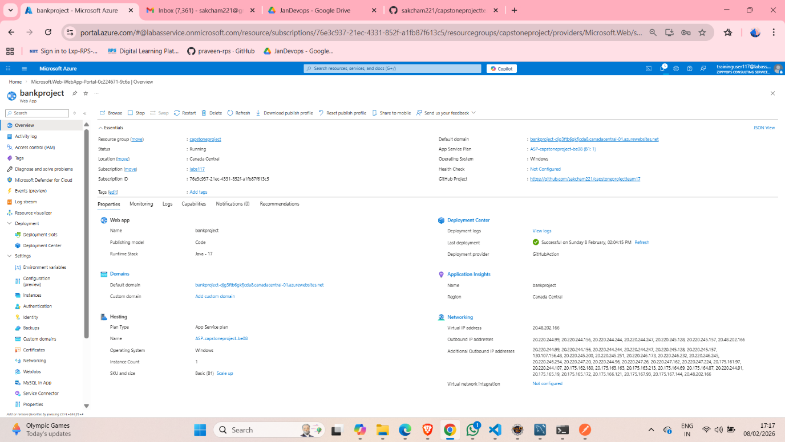

Successfully deployed the backend in Azure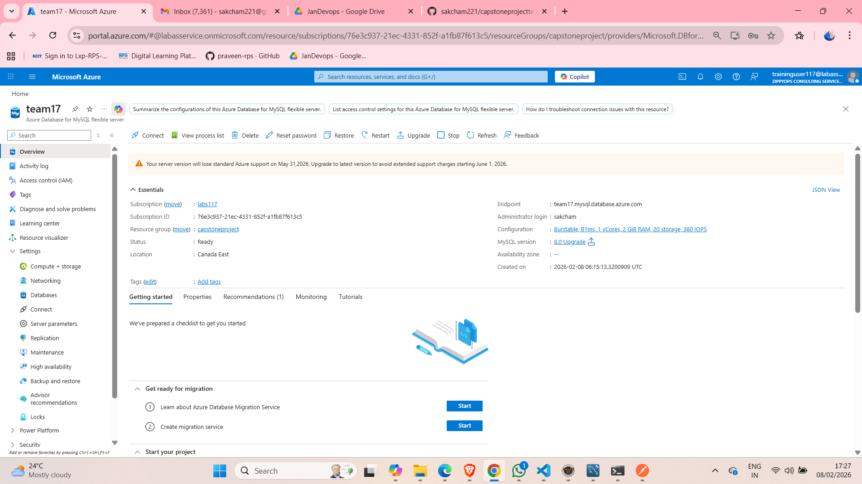

Successfully deployed the MySQL in Azure

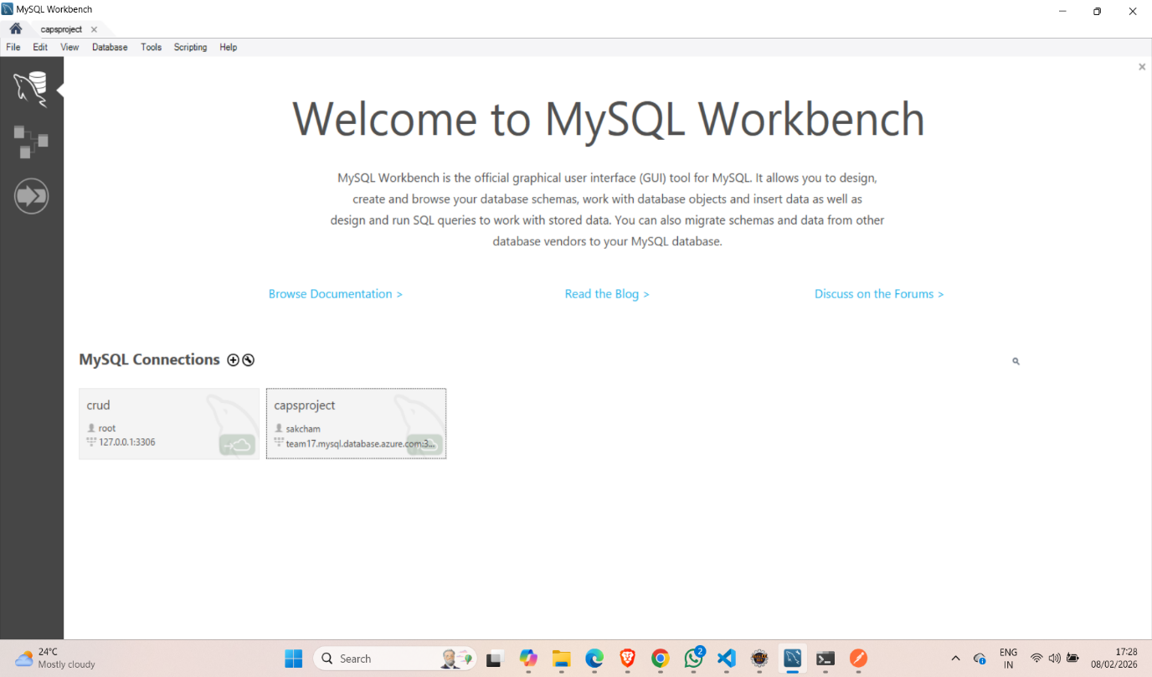

Connected the Azure with MySQL with the connection name as capsproject

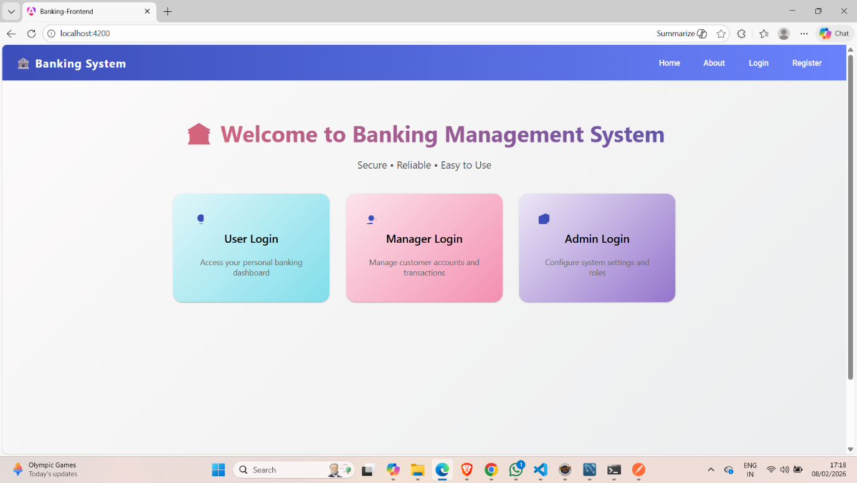

The front and the starting page of our frontend

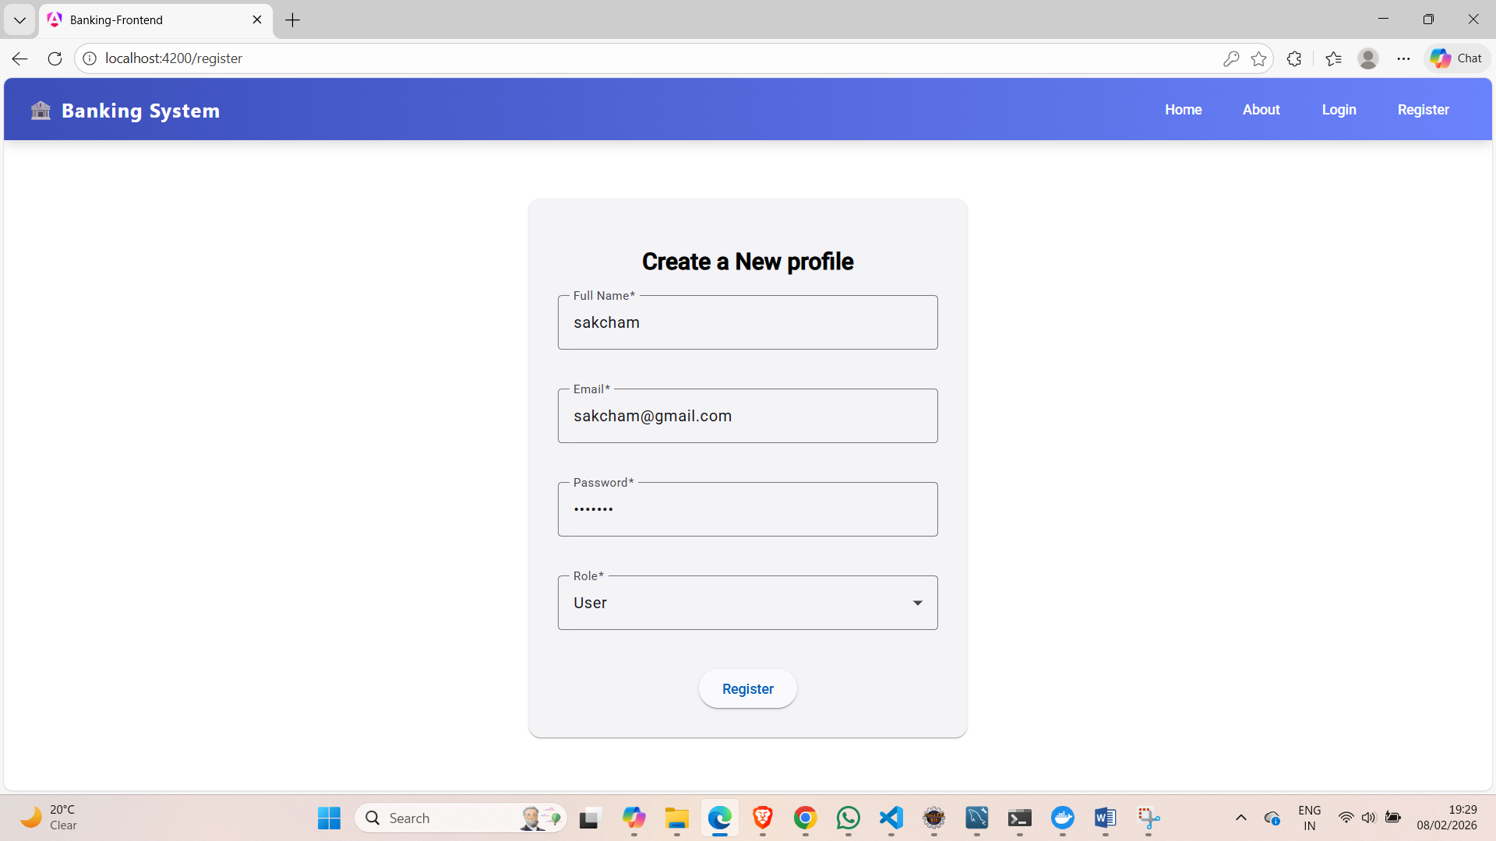Creating the new profile

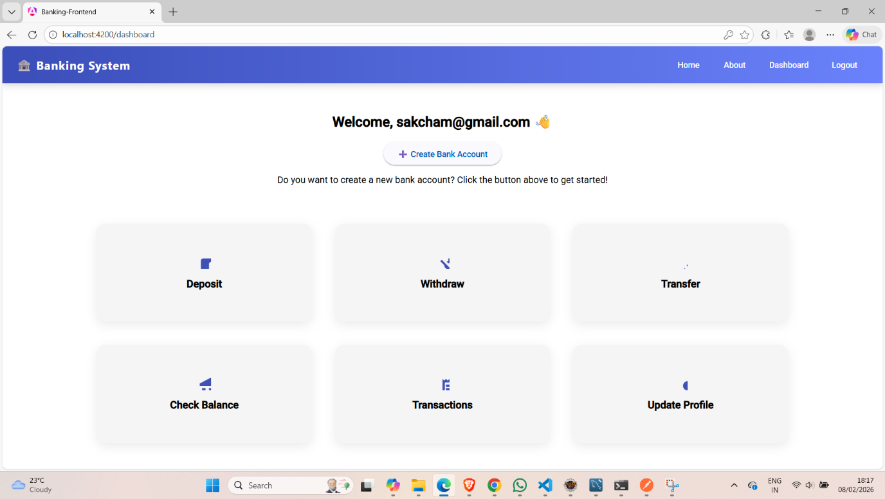

After creating the profile in the upper section getting the option to create the account and only after creating the account the user can use all the service

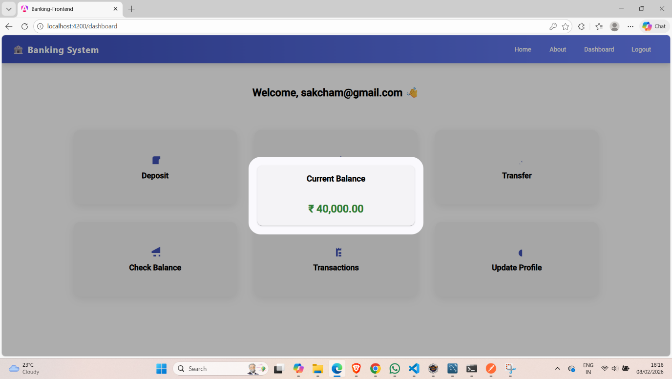

During the account creation deposit the amount of 40,000 that is been reflected in check balance

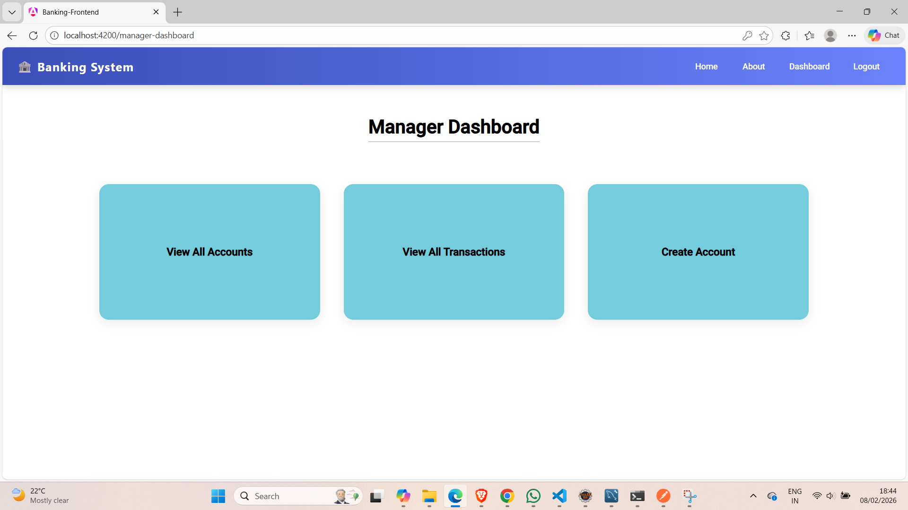

This is the manager dashboard and the manager has the authority to see all the account and view all the transaction which comes under his/her authority. And manager can even create account of any person.

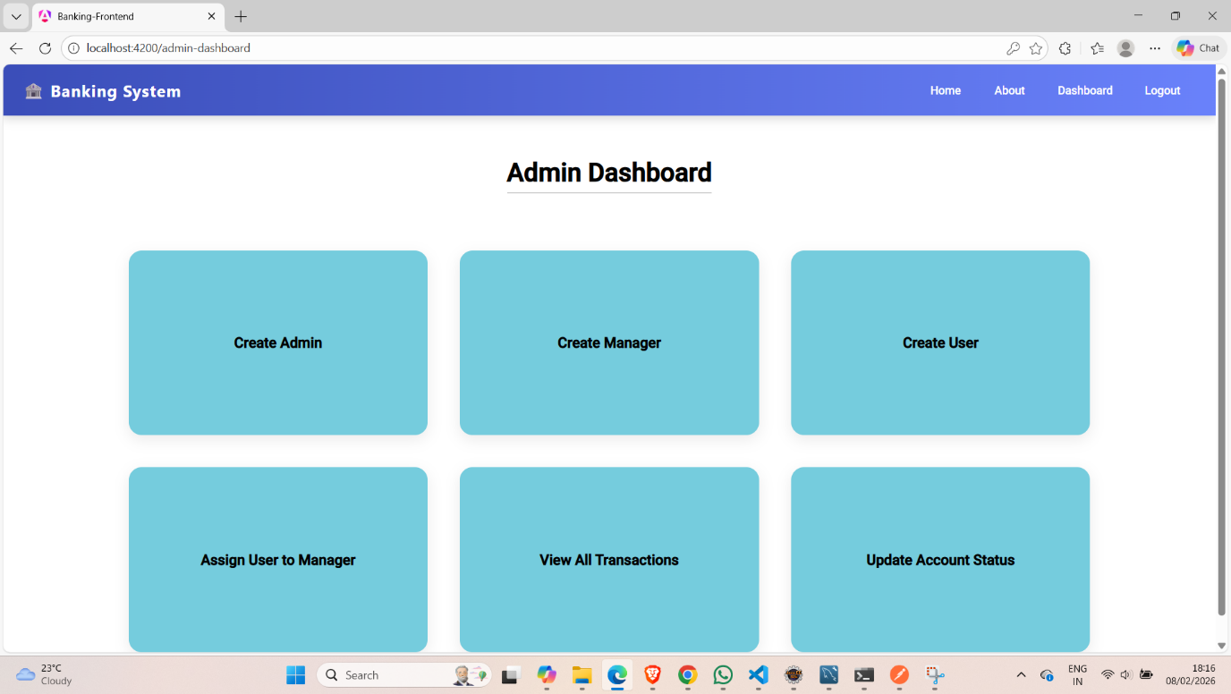

This is the admin dashboard and admin can create profile for user, manager and even for another admin and can assign the user to manager and can view all the accounts transaction and can update the account status(active, suspended, closed, pending). And he/she has the authority to make the transaction as success pending and failed.

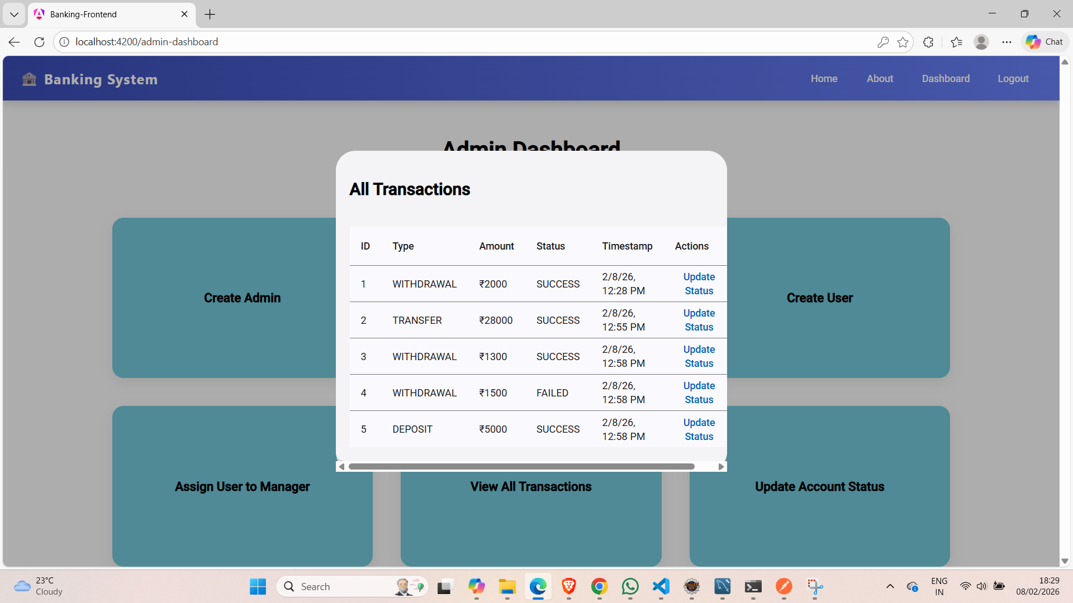

Admin can view all the transactions

Database screenshots of MySQL deployed on azure while performing the actions in the application

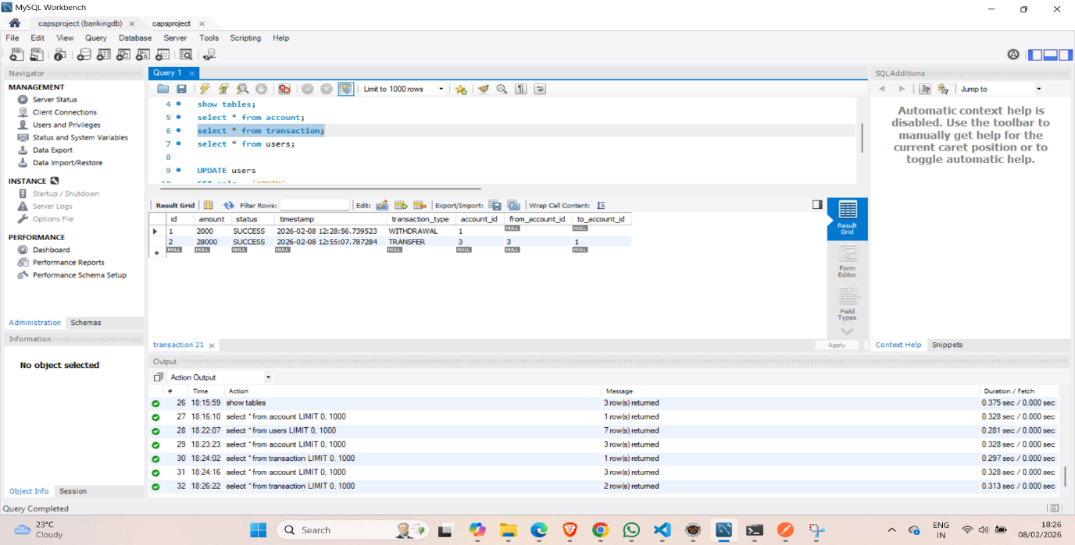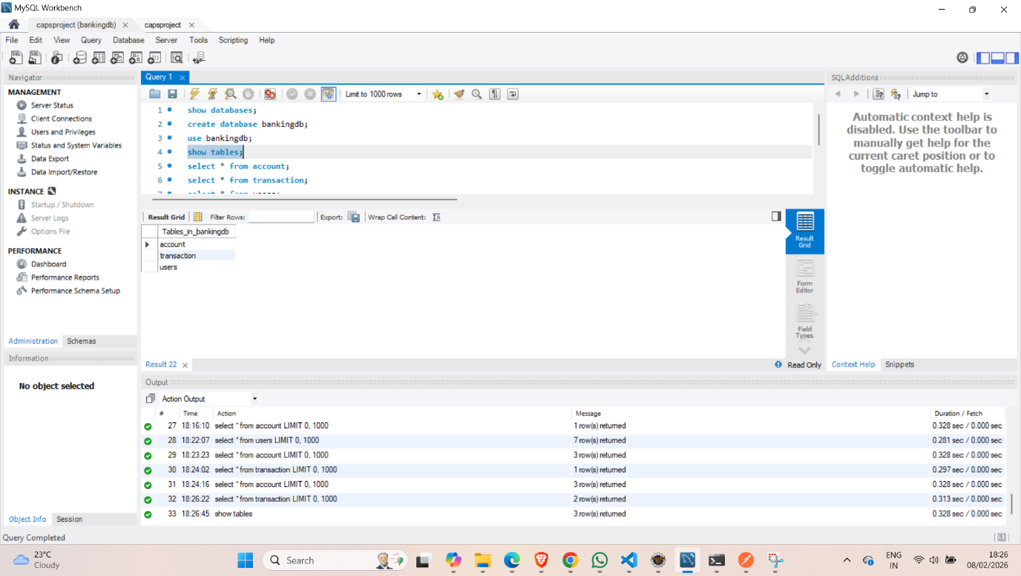

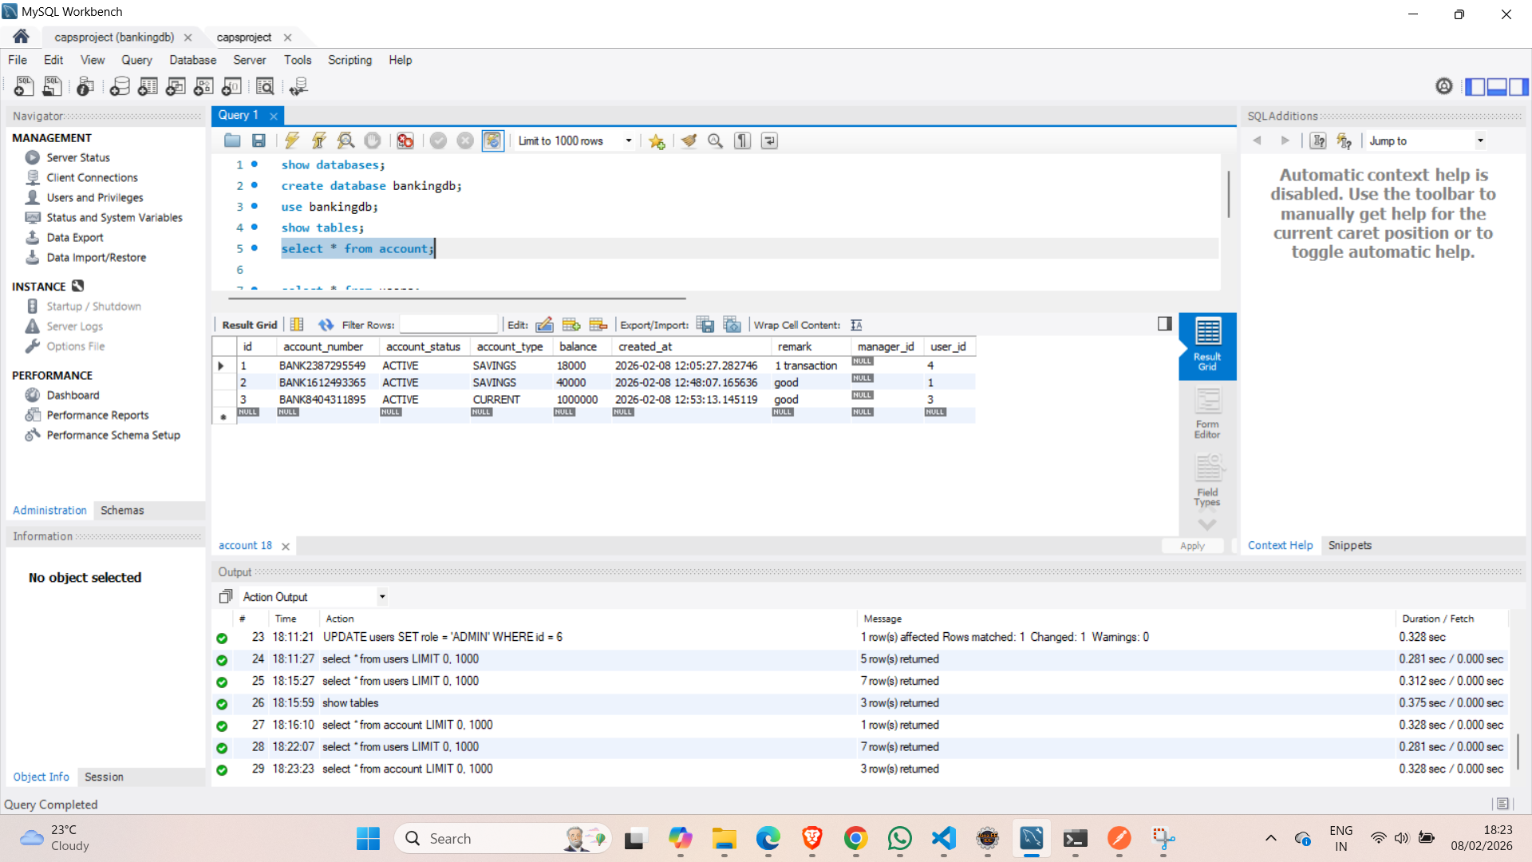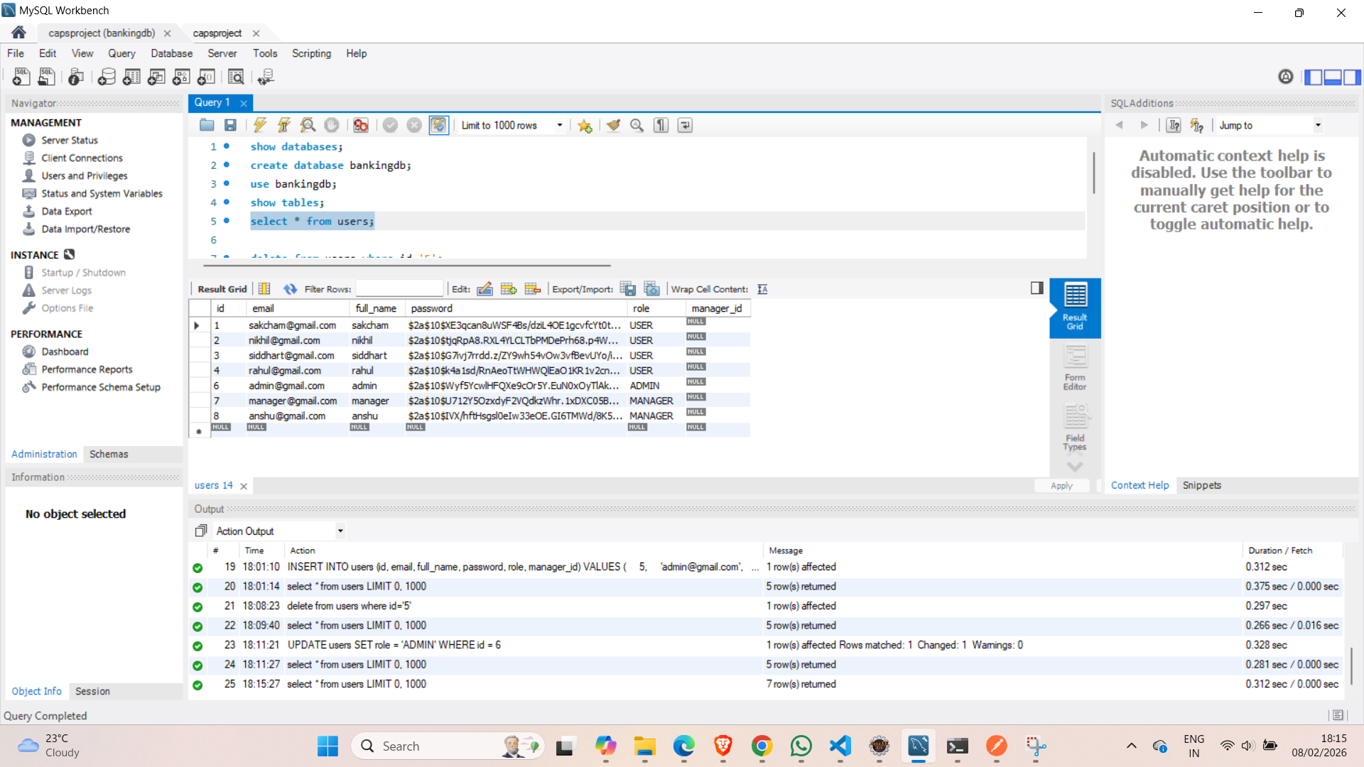

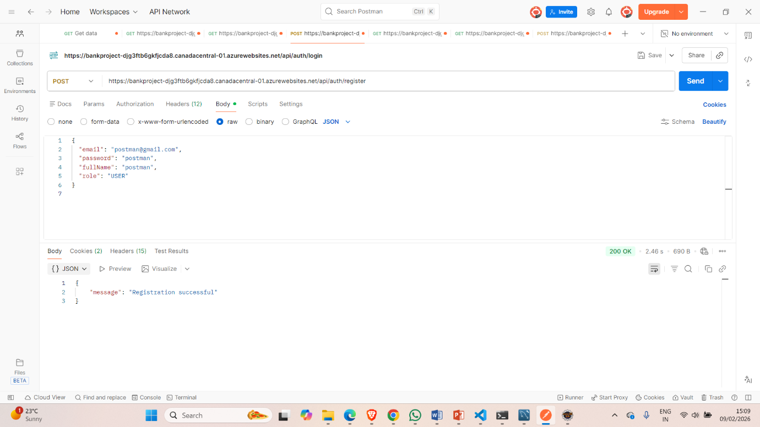

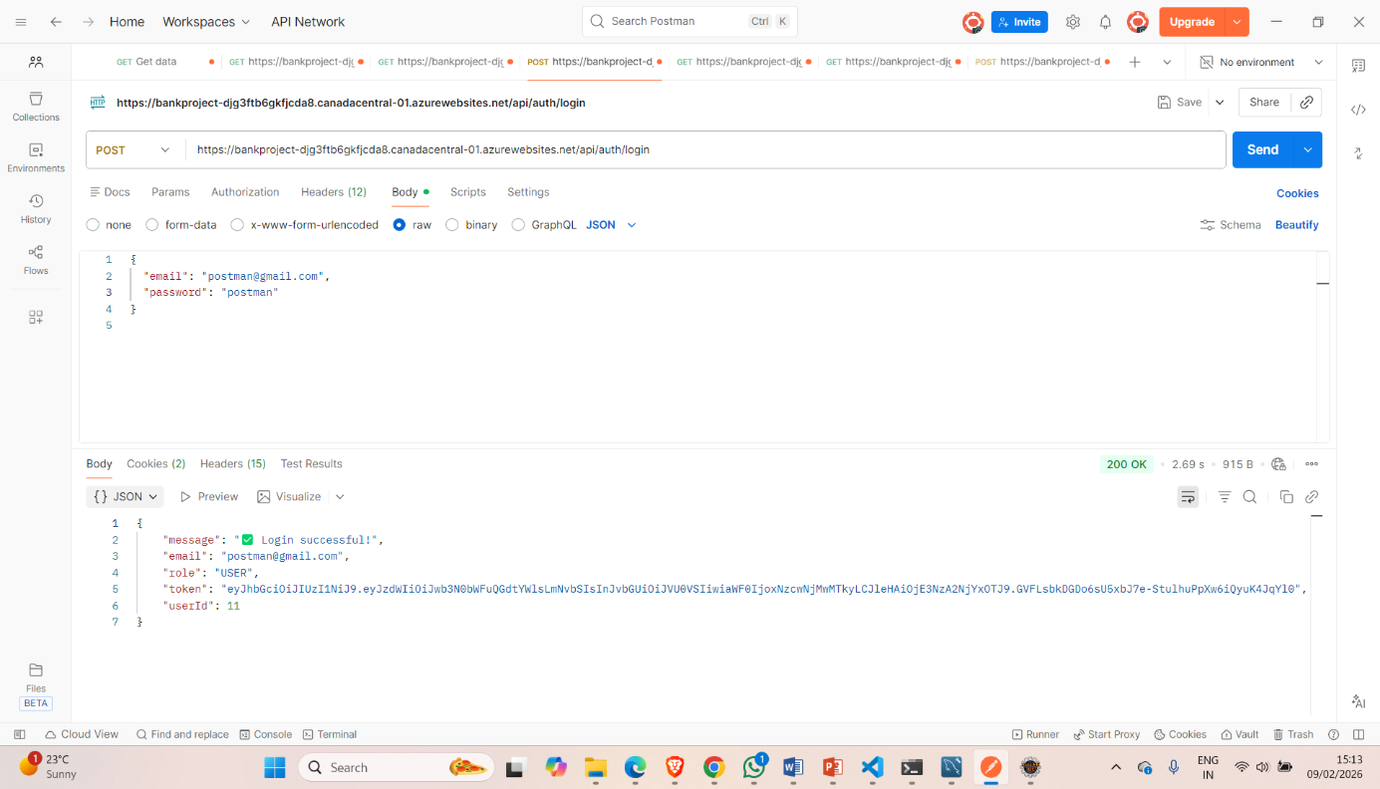

Postman screenshots of register and login